Clinical Laboratory Technology Club
Presents
FREE HEALTH SCREEN
GLUCOSE TESTING
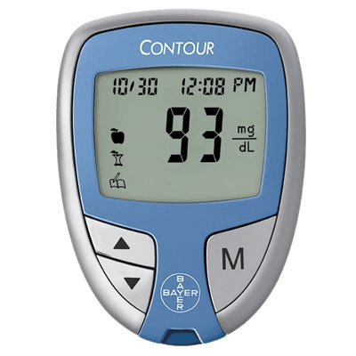
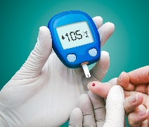
February 28th
11:30 AM - 1 PM
Campus Life Center, C1103, Marietta Campus

We will provide a FREE blood glucose lab test for the
first 50 students

Know your number and
what it tells about your health!

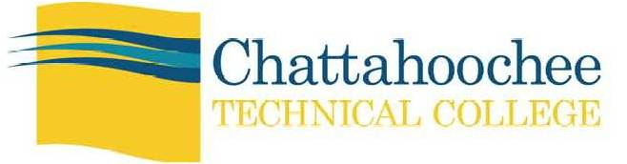
A Unit of the Technical College System of Georgia. Equal Opportunity Institution

